Namibia

## Freedom House political status

The data set shows the Freedom House political scores and status of the country each year.

## # A tibble: 19 x 5  
## country iso3c date mean status  
## <chr> <chr> <dbl> <dbl> <chr>   
## 1 Namibia NAM 1996 1 <NA>   
## 2 Namibia NAM 1998 1.5 <NA>   
## 3 Namibia NAM 2000 3 <NA>   
## 4 Namibia NAM 2002 3 <NA>   
## 5 Namibia NAM 2003 3 <NA>   
## 6 Namibia NAM 2004 3 <NA>   
## 7 Namibia NAM 2005 3 <NA>   
## 8 Namibia NAM 2006 3 <NA>   
## 9 Namibia NAM 2007 1 <NA>   
## 10 Namibia NAM 2008 1 <NA>   
## 11 Namibia NAM 2009 1.5 <NA>   
## 12 Namibia NAM 2010 1.5 <NA>   
## 13 Namibia NAM 2011 1.5 <NA>   
## 14 Namibia NAM 2012 1.5 <NA>   
## 15 Namibia NAM 2013 1.5 <NA>   
## 16 Namibia NAM 2014 1.5 <NA>   
## 17 Namibia NAM 2015 1.5 <NA>   
## 18 Namibia NAM 2016 1.5 <NA>   
## 19 Namibia NAM 2017 2 <NA>

## Freedom House classification of political change

The data set shows the GDP growth and the ecomic growth classification of the country each year.

## # A tibble: 19 x 4  
## country iso3c date politicalChangeFH  
## <chr> <chr> <dbl> <chr>   
## 1 Namibia NAM 1996 <NA>   
## 2 Namibia NAM 1998 <NA>   
## 3 Namibia NAM 2000 <NA>   
## 4 Namibia NAM 2002 <NA>   
## 5 Namibia NAM 2003 <NA>   
## 6 Namibia NAM 2004 <NA>   
## 7 Namibia NAM 2005 <NA>   
## 8 Namibia NAM 2006 <NA>   
## 9 Namibia NAM 2007 <NA>   
## 10 Namibia NAM 2008 <NA>   
## 11 Namibia NAM 2009 <NA>   
## 12 Namibia NAM 2010 <NA>   
## 13 Namibia NAM 2011 <NA>   
## 14 Namibia NAM 2012 <NA>   
## 15 Namibia NAM 2013 <NA>   
## 16 Namibia NAM 2014 <NA>   
## 17 Namibia NAM 2015 <NA>   
## 18 Namibia NAM 2016 <NA>   
## 19 Namibia NAM 2017 <NA>

## Freedom House score trend

The plot shows the Freedom House scores trend of the country.

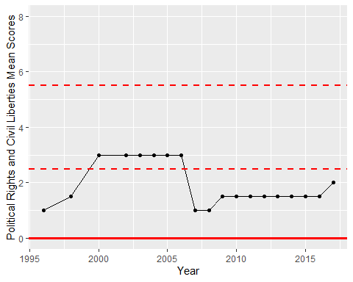

Freedom House Score Trend